|  |  |  |
| --- | --- | --- |
| SSI #:  121437  143290  143291  143319  149997  177484  177485  195631  195637  195638  195660  195661  196027  196028  196029  196135  196422  201049  201050  201700  143322 | Rev. | Task ID / Description |
| A | Mercury - PLC - new ramping PLC device implementation   Provide Beckhoff_AVT_PLC with bad inker feedback error and allow ink surge in manual mode   MC3 - AVT PLC - Allow ink surge in manual  AVT PLC Create error code system with 5 Modbus error code registers and one error count  MC3 AVT PLC sweep/water feature - Jan 5 2018 requirement chgs for AVT PLC  MC3 AVT PLC - additional register addressing in MODBUS for plate register control  MC3 AVT PLC - integrate DCOS plate register logic into the AVT PLC  AVT-PLC | When sweep trim is set at 5% and changing the sweep function to off, PLC won't turn sweep off.  AVT-PLC | Register #6 -Cir or Lat small moves (0.01) either direction; always hit the switch limit.  AVT-PLC | When the speed is zero and change register; all sweeps indicators displayed comm-errors.  AVT-PLC | if changing water function from manual to auto, then turn off; can't turn off the water.  AVT-PLC | if changing sweep function from auto to turn off; not all fountain can turn off.  AVT-PLC | Water function - Changing from AUTO to Manual, trim changed to 99%.  AVT-PLC | Register | When register moves and turn press speed to zero; register kept going until hit the limit  AVT-PLC | Register | Can't get out of limit.  MC3 - AVT PLC - CIP3 preset fountains will be forced out of OFF mode - rework  AVT-PLC - Sweep Ramping feature doesn't work.  PLC - Water output does not restore to voltages before power cycle  PLC - Water control values out of sync after power cycle  AVT-PLC - didn't update water On Press value, when using the calibration tool.  MC3 - AVT PLC: Drive ink motors by time |

|  |  |  |  |  |  |  |  |  |  |
| --- | --- | --- | --- | --- | --- | --- | --- | --- | --- |
| Type (Select 1) | Requirements Spec Status | | | Design Spec Status | | | Code Inspection Status | | |
| Enhancement | For Review  Accepted  Rejected | | | For Review  Accepted  Rejected | | | For Review  Accepted  Rejected | | |
| New Feature | Process | Name | Date | Process | Name | Date | Process | Name | Date |
| Bug Fix | Originator |  |  | Originator |  |  | Originator | Mark Colvin | 9/28/20 |
|  | Reviewed |  |  | Reviewed |  |  | Reviewed |  |  |

|  |  |  |  |  |
| --- | --- | --- | --- | --- |
| Impact | Check-In | | Carry back/over | |
| High Risk  Medium Risk  Low Risk | Checked into PVCS  Baseline: | Date | Carry back  Carry over  Branch:       Branch: | Date |

|  |  |  |  |  |
| --- | --- | --- | --- | --- |
| Systems Affected (Select all that apply) | | | | |
| Host/Console | Subsystems | Peripherals | OEM (must also select Host) | *OEM Type |
| Autosmart | CCU– PQ Camera Ctrl Unit | Autosmart Cmgr | ABB | Standard |
| Clarios | Clarios/CQD On-Press | CIP– CIP Interpreter | CANbus | Master |
| Microcolor II | Client | CN2 – Colornet II | Goss Colortrol | Slave |
| Mercury | Configuration | CQCM – CQ Cmgr | Goss Nantes |  |
| PressAnalysis | CQFG – CQ Frame Grabber | PS – PlateServer | Goss OV3 * |  |
| PrintQuick | L&A – Lights & Alarms | PDE – Press Data Export | Goss PCQ II PLC |  |
| RibbonQuick | NGOP (NGPH) | PQCM – PQ Cmgr | Goss TCS PCQ |  |
| Simulators | OCU3 |  | Goss TCS/O2 * |  |
| Internal Tools (      ) | PCU |  | HWS CPC |  |
|  | PHCM |  | KBA Colortronic * |  |
|  | PQCAM – PQ Camera |  | KBA Densitronic |  |
|  | RCU – Ribbon Control Unit |  | KBA Colortronic SCL | Documentation |
|  | RPLC – RIO PLC | PLC | Komori PQC-IV | Manual(s) |
|  | RQCAM – RQ Camera | Chambon | MAN Pecom04 | Service Note(s) |
|  | Server | Goss | MAN Pecom95 | Release Notes(s) |
| Other Systems | Servo2+ | Hantscho | MAN Pecom90 | Install Docs |
| Jupiter | SVO – Servo | Mitsubishi | MLP API | Theory of Operation |
|  | SpectralLab SMU | Toshiba | Mitsu II * | (Other) |
|  | SPU | RIO/Rabbit |  |  |
|  | SPU3 | (Other) | (Other) |  |
|  | TCM – CQ Timing Control |  |  |  |
|  | TCMR–PQ Timing Control |  |  |  |
|  | (Other) |  |  |  |

Requirement Specification Details: (If separate document) See SDS

# General Description of the Task and its Desired End Result / Description of the Problem Found (Bug Fix)

# Interface Requirements (Specify type of interface such as User, Communication, etc.)

March 2017 customer requirements – original P62 console shown below

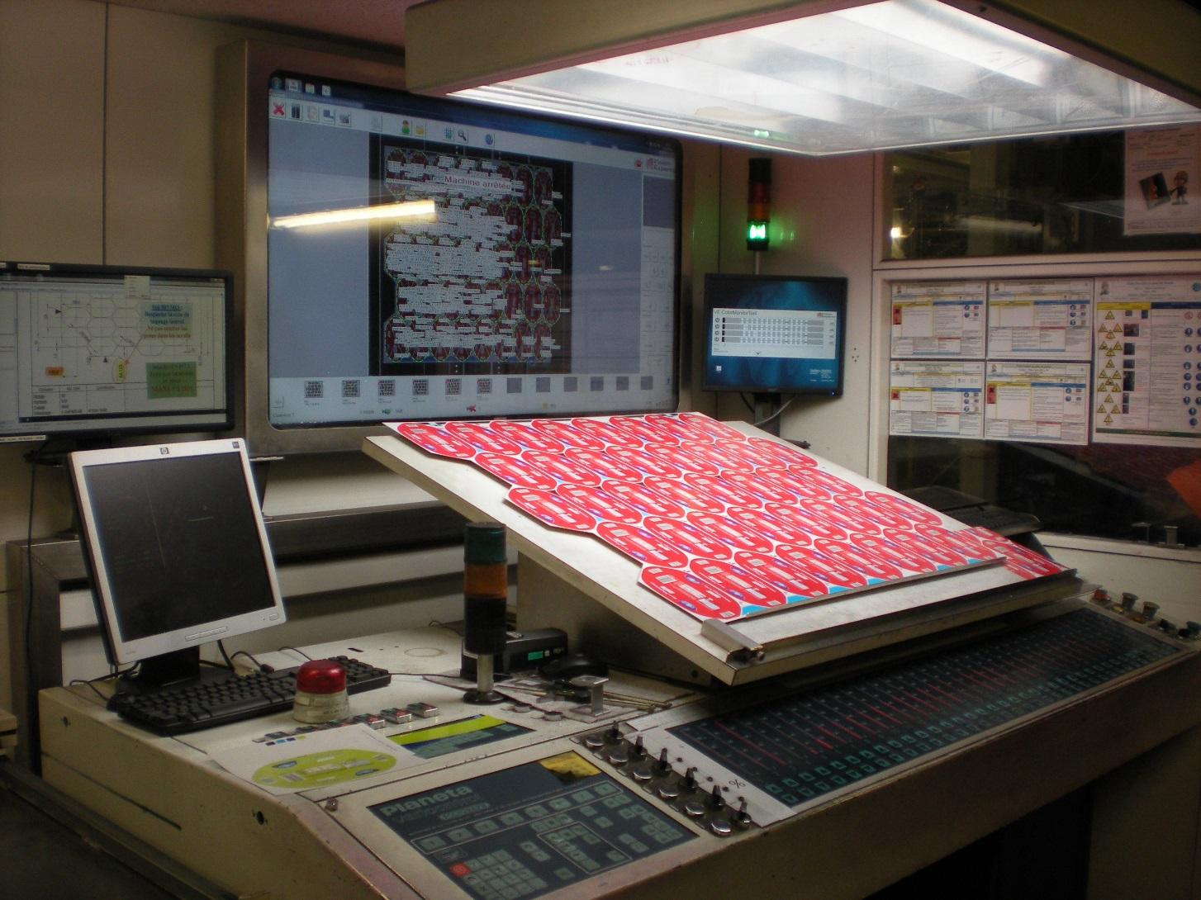

Customer has 3 press lines of 6 color Planeta Varicontrol metal decorator sheet fed presses. Two have been upgraded to these changes…

They purchased Mercury upgrade of fountain keys, sweep and water controls, ramping adjustments with press speed, ink washup, ink surge, ink ductor control, water flood. Customer wanted to extent existing AB PLC controls, but we insisted on Beckhoff PLC electronics as the extension to the Mercury RIC controls.

Additionally added was manual control of plate register system.

Original May 2017 requirements:

* Sweep and Water controls for Ardagh will be somewhat specialized. A hybrid of standard sweep / water controls combined with ramping and ductor hold-off features.
* No ink ramping required on this installation as the fountain roller is mechanically driven.
* Ductor Hold-Off WILL be employed on this install.
* Ductor Hold-Off currently controlled in Ardagh PLC. We will take over this feature. Output is yet TBD.
* Water ramping WILL be employed on this install.
* Water ramping currently controlled in Ardagh PLC. We will take over ramping curves in Mercury. Output will be 0-10V to the Ardagh PLC to control the water motors.
* An encoder input of some type will be required. Design TBD. Must be ±1% accuracy of actual press speed.
* Unit mounted controls. A touchpad shall be mounted at each unit to mimic some basic controls of the Mercury GUI as they pertain to Sweep and Water functions.
* **PLC** – We will require a PLC that can handle all of the necessary functions. These include, but are not limited to, the following:
  + **Encoder Input x1** – This may include A, B, and Z channels. Required for speed indication and ramping control. One speed encoder for entire press.
  + **Digital Input x6** – These will likely be sensors mounted on each press unit and will signal when the ductor hold off on that unit will activate.
  + **Analog Output x6** – 0-10V (variable, depending on setting and press speed) will be supplied to the Ardagh PLC to control the water motor speeds. Water motors are continuous run during production. One water motor on each unit. Ardagh will need to disable ramping on their PLC.
  + **Digital Output x6** – Voltage TBD. Required to control the air cylinder for Ductor Hold-Off. The air cylinder is either on or off and the frequency / timing of the on/off state is controlled by the setting (0, 25, 50, or 100) and by the analog input outlined in bullet 2 above. One air cylinder on each unit. Control of these will move from the Ardagh PLC to the AVT PLC.
  + **Digital Output x6** – Voltage TBD. Required to control position of sweep motor. The sweep motor positions a cam so the motor only moves if a new sweep value is desired. This motor is either on or off and runs in both directions. It may be a DC stepper motor or an AC synchronous motor…totally unknown at this point. One motor on each unit.
  + **Digital Output x6** – Voltage TBD. Required to run the separate wash-up motor. This motor runs under two conditions. One is when the HAND option is used in the Sweep All screen. The other is during the Ink Surge function. This motor is either on or off and only runs in one direction. May be AC or DC. One motor on each unit.
* Current PLC candidates are ADAM (various models required) and Beckhoff (single model required for all functions, various modules to handle different functions.) Will likely need a new PLC type in Sitegen with highly configurable features / functions as defined on the following slides.
* **Ink Surge**
  + This button shall run the ink sweep at 100% for a pre-determined amount of time. (Runtime Option) The button can be pressed multiple times to add to the surge time. So, if the preset time is 3 sec., then the surge will be set for 3 sec. if the button is pressed once. If the button is pressed twice, the total surge time will now be 6 sec. The RUN button must still be used.
* **Flood**
  + This button shall run the water control at 100% for a pre-determined amount of time. The button can be pressed multiple times to add to the flood time. (Basic functionality is the same as the Ink Surge.)
* **Cancel / Countdown Timer (Ink Surge & Flood)**
  + This button is shown on both the Status screen and the Sweep All / Water All screens. It has two functions. The first function will immediately cancel the Surge or Flood signal when pushed. It will also cancel any time showing if the Surge or Flood button was pressed, but the RUN button was not selected.
  + The second function of this button is to show the preset time or the time left for the surge or flood after the surge or flood button has been pressed. (This is the nn part of the button) Each time the Ink Surge or Flood button is pressed, this timer will display the cumulative amount of time still left for the surge. Limit to two digits.
* **Function (Sweep and Water) –** These buttons have three states. Each press of the button will toggle the function to the next state. The three states are:
  + OFF
  + HAND
  + AUTO
* When **OFF** is selected, the sweep or water for that unit should be set to zero. No need to select RUN after this state is selected.
* When **HAND** is selected, the sweep or water should be activated and run at the pre-determined speed. (In the Runtime Options) However, for THIS state only, the RUN button must be pushed. The reason for this is so the sweep or water motor will not inadvertently start running at wash-up speed just by toggling through the various states.
* The **AUTO** setting means that the sweep or water will run at the setting shown on the dial. Also, *if ramping is enabled*, then the sweep or water will follow the pre-defined ramping curves as the press increases or decreases in speed. No need to select RUN after this state is selected.
* **Surge All**
  + This button will send the surge signal to all fountains. There are prerequisites to what is considered “all fountains”. These are:
    - The fountain must be part of the same split.
    - The fountain must be in AUTO mode.
  + After setting the desired surge time, the RUN button must be used.
* **Flood All**
  + This button will send the flood signal to all fountains. There are prerequisites to what is considered “all fountains”. They are:
    - The fountain must be part of the same split.
    - The fountain must be in AUTO mode.
  + After setting the desired flood time, the RUN button must be used.
* **Access Ramping Screens**
  + This button should appear when ramping is enabled and will be present in the system menu. (Along with ELO Calib, Splits, etc…) Selecting this button will open the Ramping Screen.
* **Ductor Control**
  + This button will have 4 states. Each press of the button will toggle to the next state. The 4 states are 0, 25%, 50%, and 100%.
  + After toggling to the desired state, the RUN button must be used.
  + The output to the press will control an air cylinder that changes a mechanical position of an arm or cam in the press. The air cylinder is currently controlled by the Ardagh PLC. So perhaps we can just output a signal to this Ardagh PLC to do the selection of the ductor state. At the time of this writing, this is an unknown.
* **Copy To Unit**
  + Using this button will copy the values in all 20 steps for the selected unit and apply them to another inker in the same Curve Preset. (Paper Type)
  + When selected, the operator should be prompted to select another inker to copy the values to. (Similar to the operation for copying ink zone settings.)
* **Copy Curve To Preset**
  + Using this button will copy the values in all 20 steps to another Curve Preset. The operator should have the opportunity to copy these values to only the selected inker in another Curve Preset OR allow the operator to copy the values to ALL inkers in a different Curve Preset.
* **Restore Linear**
  + Use of this button will restore a linear curve between Step 1 and Step 20.
* **Cancel**
  + Functions like the Cancel button in all other Mercury screens. No changes will be saved and the screen will be exited if this button is used.
* **Accept (Green Check)**
  + Functions like the Accept button in all other Mercury screens. All changes to that point are accepted and the screen will be exited if this button is used.
* **Help**
  + Use of this button should take the operator to the appropriate entry in the manual. (User, Training, Service, etc.)
* **Ink Ramping (Not needed for Ardagh)**
  + Button has two states, selected or unselected. If in the Water Ramping screen then this should show as unselected. May be omitted if Ink Ramping not enabled on system.
* **Water Ramping**
  + Button has two states, selected or unselected. If in the Ink Ramping screen then this should show as unselected. May be omitted if Water Ramping not enabled on system.
  + Main view changes for sweep and water controls:

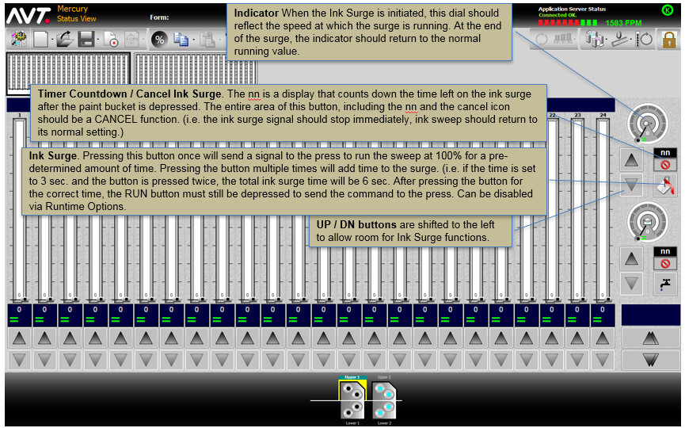

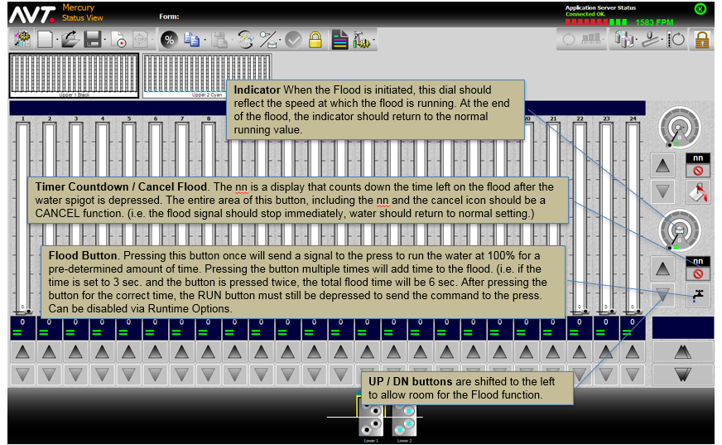

Sweep All view:

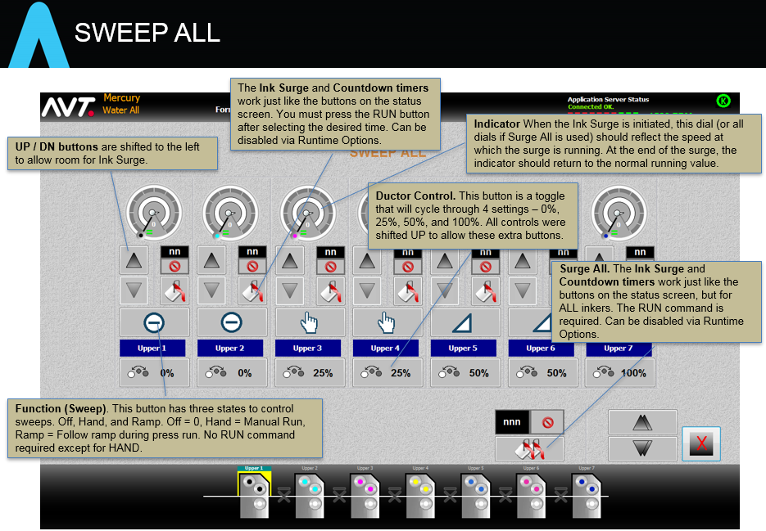

Water all view:

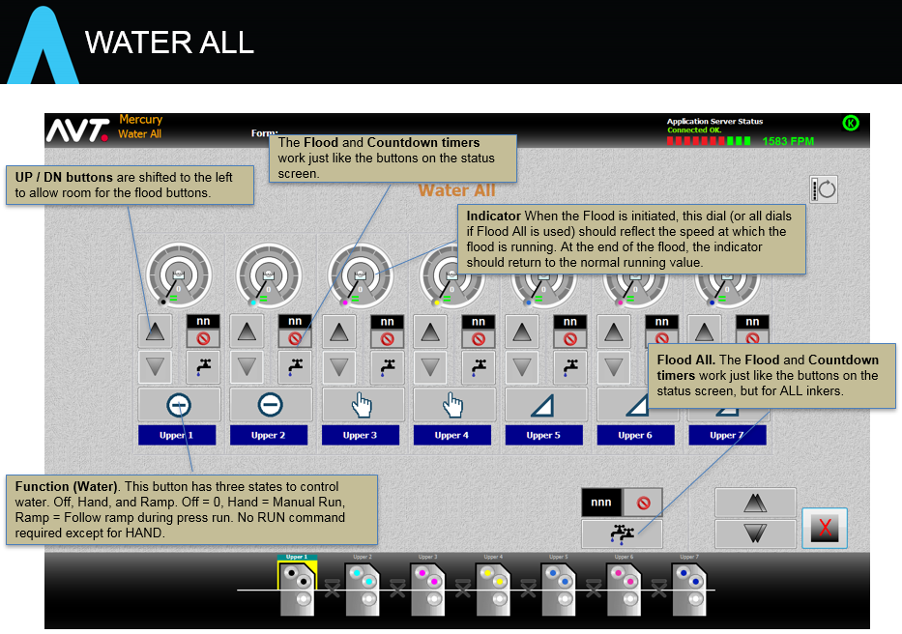

Ramping for Water

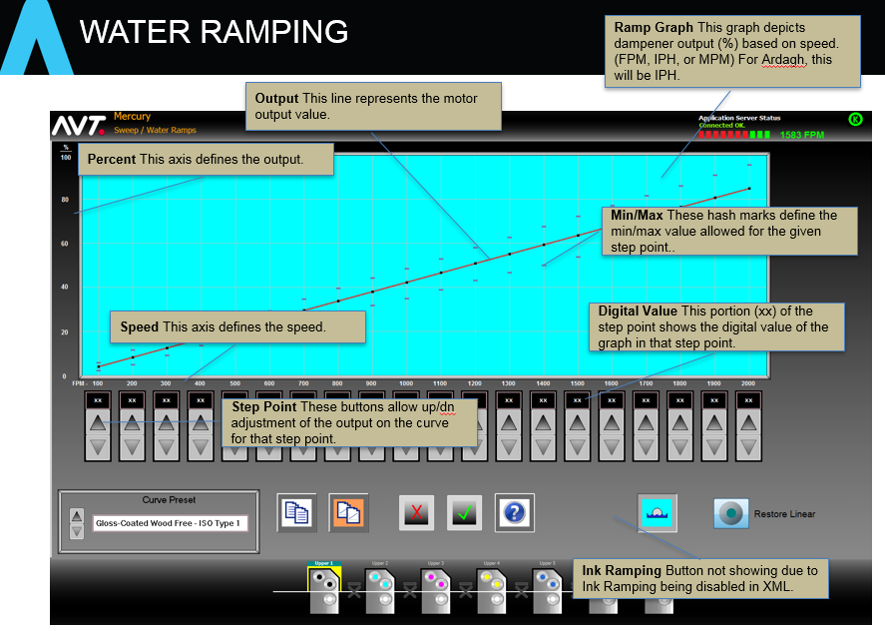

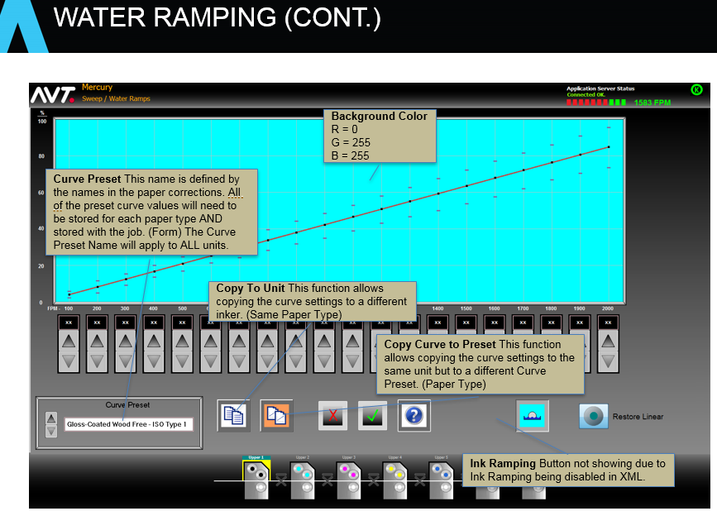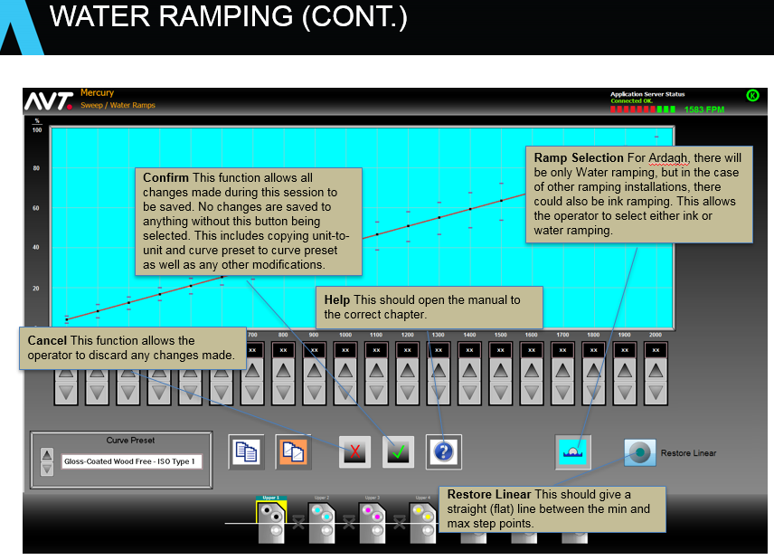

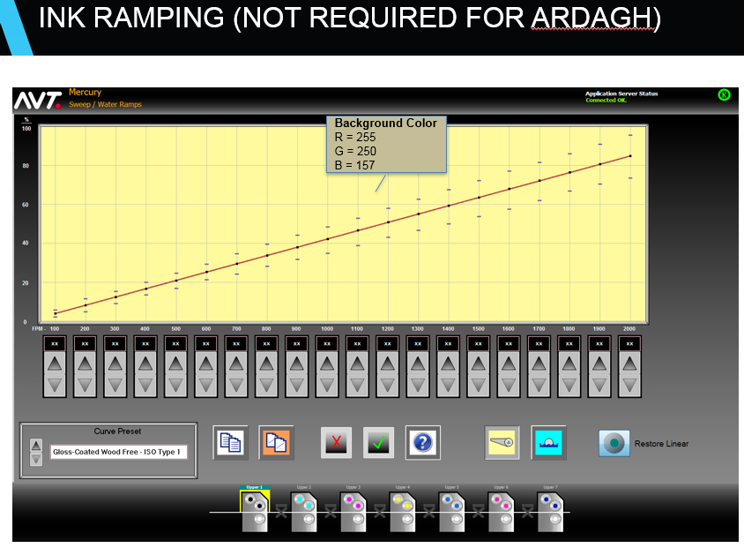

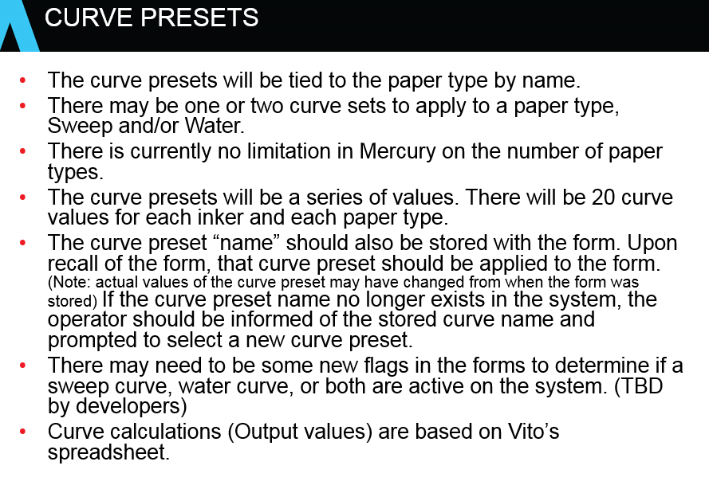

# Functional Requirements

# Performance Requirements

# Other Requirements

Design Specification Details: (If separate document) See SDS:

# Root Cause Analysis: (Bug fix)

# Theory of Operation: (Describe all algorithms and sequence of events within the task)



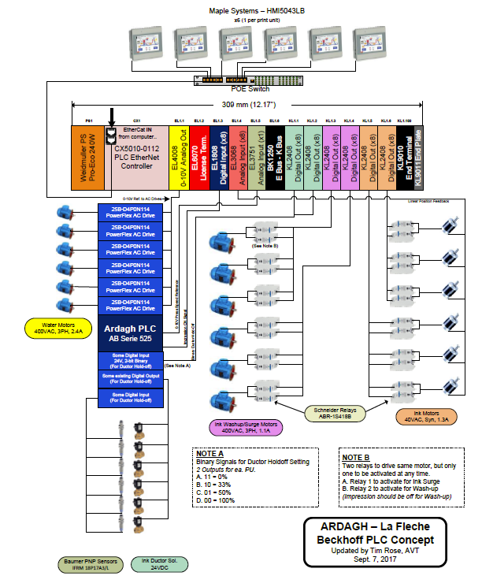

This next DIN rail is additional to the sweep and water controls above: (there is an Ethernet CAT5 cable connecting the Two DIN rails)

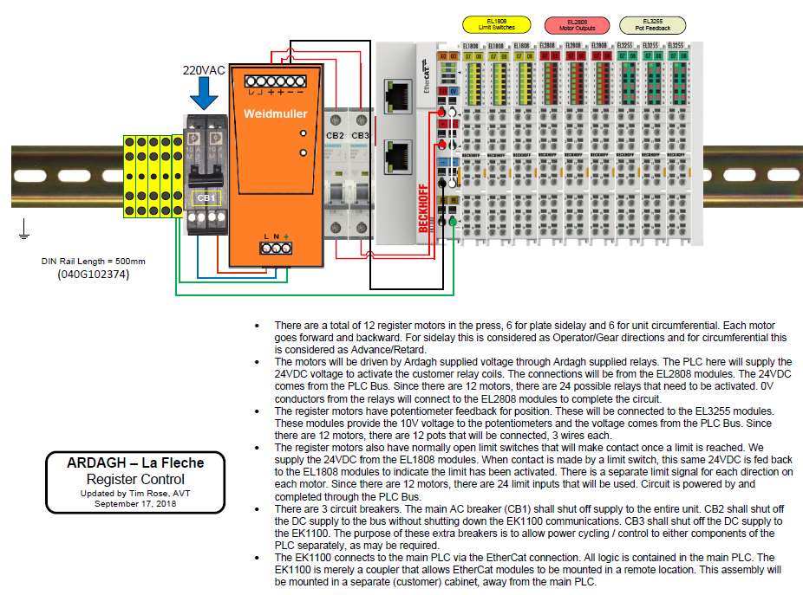

**AVT PLC – Sweep/Water and Manual Register Control Processes 11-16-18**

Rev C mac

Main Loop

* Process PLC Sweep / Water Settings Initialization
* Process Ramping Curve Data Initialization
* Process Register Settings Initialization
* Process Impression-On and Speed I/O
* Process Sweep/Water Function and OFF settings
* Process changes in Sweep Control and Ramping
* Process changes in Water Control and Ramping
* Process changes in Surge and Flood settings
* Process changes in Ductor settings
* Process changes in Ink Washup settings
* Process changes in Register Control settings
* Process changes in Real Time Support
* Loop

**Basic order of Register Feature (per PLC cycle)**

Process Limit Switches and Pot Feedback

Main Register Motor Control Logic

Process Motor Location and Status Booleans

Process Motor Relay outputs

App Server Interfaces:

**Initialization**

Basic process of initialization process:

App Server loads MODBUS initialization addresses with XML data

App Server enables the initialization Boolean

PLC processes data at MODBUS addresses, mostly moves data to PLC memory.

PLC clears initialization Boolean when done.

**Register Initialization**

**Register Settings from App Server**

**Setting values Comment Example**

|  |  |  |
| --- | --- | --- |
| Minimum position | Relative to 0.00 mm from center | -300 |
| Maximum position | Relative to 0.00 mm from center | 300 |
| Feedback position at min | Pot feedback voltage at min | 6553 |
| Feedback position at max | Pot feedback voltage at max | 26214 |
| Velocity (Slope) | Set in µm/s | 100 |
|  |  |  |
| **SETUP BITS** |  |  |
| Enable feedback | calculate status position using pot feedback | TRUE |
| Enable Feedback positioning | if 1= calc moves with pot feedback, else moves will use Velocity | FALSE |
| Enable 2 limit switches | 1 = 2 limit switches enabled | FALSE |
| Invert feedback | max feedback will be min | FALSE |
| Invert outputs | outputs will be inverted | FALSE |
| Enable 1 limit switches | 1 = 1 limit switch enabled | FALSE |

|  |
| --- |
| Example settings of a register +/-3mm |
| with pot voltage 2V at min setting and 8V at max setting – PLC will make this calc |
| 2V = 32767 * 0.2 = 6553.4 |
| 8V = 32767 * 0.8 = 26213.6 |
| Moving 0.1mm/s (slope) |

Settings in blue should be configured in the PLC, for first phase.

All voltages sent to PLC are x1000. (whole number)

All position targets and settings to PLC are millimeters x100. (whole number)

**Register Commands for each motor of each inker**

Seek Center position

PLC has routine to seek both limit switches and stop in the center position.

No target value needed, App Server sets the Boolean and waits for the centering status to show centering and then centering will reset when done. App Server should check the error Booleans for any problems during the move.

Make relative adjustment move of motor

App Server supplies the relative move, plus or minus in MM x100, to Control position value. Then the App Server sets the Relative Move control Boolean. PLC will set the moving status. App Server can monitor the status position in real-time. This position will be from the pot feedback detection, relative to center in MM x100. The PLC will reset the moving status Boolean when move is complete. App Server should check the error Booleans for any problems during the move.

Make absolute adjustment, pulse (Rising Edge)

Not used at this time.

Stop all movements, momentary

App Server will set this Boolean to stop the motor immediately. Not sure if the PLC will reset this Boolean when stopped.

Reset, pulse (Rising Edge)

Used to reset stuck motor condition

**Register Status Monitoring**

* Moving to pins or to gear side

Motor is moving toward positive limit

* Limit to pins or to gear side

Limit switch on positive side has been activated

* Moving from pins or to operator side

Motor is moving toward negative limit

* Limit from pins or to operator side

Limit switch on negative side has been activated

* Is centering

Centering process is operating

* Is making relative adjustment

A relative move has been requested

* Is making absolute adjustment

An absolute move has been requested

* All movements stopped

PLC has received a motor stop request and stopped motor

* Error - Centering time out

Center process took too long, not sure how long this time is , yet.

* Error - stuck motor

Motor movement is not detected by pot feedback changing

* Error - incorrect parameters

Bad data to register motor setup.

**IDE testing of PLC Register feature**

The Main code of the Register feature is located in these modules: (.TcPOU files)

MAIN (near the end of the main loop)

FB_AVT_Register (entire file)

The data arrays are in the GVL and GVL_IO files.

GVL file contains this array:

**W_RegisterConfig** :Array[0..w_MAXFOUNTAINS, 0..9, 0..w_MAXREGISTERMOTORS] of INT;

//Register configuration (ftn, option, motor) motor is circ,lat,skew

And the MODBUS output registers

Relevant constants for register feature:

iCIRC :WORD:=0; // motor directions

iLAT :WORD:=1;

iSKEW :WORD:=2;

iMinus :WORD:=0; //gear

iPlus :WORD:=1; //oper

RUNREG_START :WORD:= 152; //this is start of 7th fountain runtime space for register runtime data(overlap)

RUNREG_SIZE :WORD:= 4;

//this is the size of the runtime space for each motor - modbus[start+(ftn*size+direction*size+type*size)]

iActualPosition :WORD:= 0;

iRequestedPostion :WORD:= 1;

iBoolStatus :WORD:= 2;

iBoolControl :WORD:= 3;

I modified the IDE settings in the PLC development to use the Control-Shift-Period keystroke to ForceData for MODBUS data array change to PLC memory.

The key to the Runtime Control and Status Booleans are located in PLC Design XLS files, are listed here:

|  |  |  |  |
| --- | --- | --- | --- |
|  |  |  | Mask |
| Index | **Bit declaration** | PLC Register STATUS booleans |  |
| **WORD2** | **Register Status** | comment |  |
| .0 | Moving to pins or to gear side | motor move direction to gear side | 1 |
| .1 | Limit to pins or to gear side | gear side limit switch is activated | 2 |
| .2 | Moving from pins or to operator side | motor move direction to oper side | 4 |
| .3 | Limit from pins or to operator side | Oper side limit switch is activated | 8 |
| .4 | Is centering | centering process engaged with limit switches | 16 |
| .5 |  |  |  |
| .6 | Is making relative adjustment | motor move in progress | 64 |
| .7 | Is making absolute adjustment | not used | 128 |
| .8 | All movements stopped |  | 256 |
| .9 |  |  |  |
| .10 |  |  |  |
| .11 |  |  |  |
| .12 |  |  |  |
| .13 | Error Centering timeout |  | 8192 |
| .14 | Error stuck motor | Feedback not moving or moving incorrect direction. if set, moves are inhibited & must be reset | 16384 |
| .15 | Error incorrect parameters |  | 32768 |
|  |  |  |  |
| Index | **Bit declaration** | PLC Register CONTROL booleans |  |
| **WORD2** | **Register Control** | comment |  |
| .0 |  |  |  |
| .1 |  |  |  |
| .2 |  |  |  |
| .3 |  |  |  |
| .4 | Centre, pulse (Rising Edge) | Activated centering. If feedback go to 0. If limits goto center cycle. Else no function | 16 |
| .5 |  |  |  |
| .6 | Make relative adjustment, pulse (Rising Edge) | Move to relative position based on control word 1 | 64 |
| .7 | Make absolute adjustment, pulse (Rising Edge) | Move to absolute position based on control word 1 (can not be used when no feedback) | 128 |
| .8 | Stop all movements, momentary | cancel all moves | 256 |
| .9 |  |  |  |
| .10 |  |  |  |
| .11 |  |  |  |
| .12 |  |  |  |
| .13 |  |  |  |
| .14 | Reset, pulse (Rising Edge) | reset stuck register flag | 16384 |
| .15 |  |  |  |
|  |  |  |  |

The MODBUS output registers Array contains the RUNTIME data for Register Feature, starting at 152:

Each motor contains 4 entries:

Actual position, Requested position, Status Booleans, Control Booleans

Each fountain has 3 motors: Circ, Lateral, Skew

Forcing data values into the Requested position and Control Booleans will perform various register operations in the AVT test fixture.

Using the mask values in the above chart will start the command to the feature.

Note the Realtime status Booleans show what is currently operating in the motor move logic.

**Index for each motor starts at these addresses**:

152 Circ U1 188 Circ U4

156 Lat U1 192 Lat U4

164 Circ U2 200 Circ U5

168 Lat U2 204 Lat U5

176 Circ U3 212 Circ U6

180 Lat U3 216 Lat U6

**To make the centering process start**, use the mask value of 16 in Control Boolean value

Leave the value in place until the process is done.

The process will be performed: Seek the plus limit switch, then seek the minus limit, then position in the center distance between the switches.

The actual position value will be near zero. Negative values in MODBUS arrays will show with the MSB set (65536 and lower).

**To make a relative move,** enter a delta position in the Requested position value. This can be positive or negative value of mm x100. Then set the value of 64 in the control Booleans. After setting the relative move Boolean, then enter a ZERO in control Booleans. See actual position value for end result. Status Booleans will show current status during move and then any error conditions.

**To reset error conditions,** enter a reset pulse in the control Booleans, 16384. Then enter a zero.

The relative motor moves will accept several updates without completing the moves. The Centering process should NOT be interrupted while in progress. If any error conditions occur in the centering process, it should be reset in the next command to recover properly.

**To stop the motor immediately,** enter the 256 boolean value in the control Booleans. Then enter a zero.

# User Interface Related Changes/Additions: (Describe all UI additions and changes expected)

## Purpose

## Inputs

## Processing

## Outputs

## Changes/Additions to Title/Configuration/Menu

# Internal System Related Changes/Additions: (Describe all additions and changes expected)

## Purpose

## Inputs

## Processing

## Outputs

## Change/Addition title

# Global Structure (Class) Requirements: (List all global structure changes and additions expected)

|  |  |  |  |
| --- | --- | --- | --- |
| NEW / REV | CLASS / STRUCTURE NAME | TYPE (Size) | DESCRIPTION |
|  |  |  |  |

# Global Variable Requirements: (List all global variable changes and additions expected)

|  |  |  |
| --- | --- | --- |
| NEW / REV | TYPE (Size) | DESCRIPTION |
|  |  |  |

# Network Message Requirements: (List all network message changes and additions expected)

|  |  |  |  |  |
| --- | --- | --- | --- | --- |
| NEW / REV | SYSTEM | | PROTOCOL  (Ethernet, Serial) | DESCRIPTION |
| FROM | TO |
|  |  |  |  |  |

# Resource String Changes/Additions

|  |  |  |  |  |
| --- | --- | --- | --- | --- |
| NEW/ REV | MESSAGE ID | TEXT | MAX LTH | TRANSLATE  (Y/N) |
|  |  |  |  |  |

Implementation Details: (If separate document) See SDS:

# Changes Made to Implement the Task: (Describe changes made)

Mercury 1.70 release (and later) must be used.

**Sweep PLC source files: POU and GVL style source file of Structured Text PLC logic:**

MAIN.TcPOU Main loop of PLC logic, handles initialization, Profibus connection, sweep console and on-press data handling

CheckBounds.TcPOU Array bounds checking

CheckDivDInt.TcPOU Double integer divide by zero checking

CheckDivLInt.TcPOU Long integer divide by zero checking

CheckDivLReal.TcPOU Long (double) Real divide by zero checking

CheckDivReal.TcPOU Real divide by zero checking

FB_AVT_Register.TcPOU PLC register motor moves by time and pot feedback, with limit switches. Single motor per instance

FB_FunctionChange.TcPOU Sweep and water, handling transitions between MANUAL, AUTO, and OFF.

FB_PlusMinusByTime.TcPOU Motor positioner by time, configurable for fast or slow motor – NOT COMPLETED

FB_PlusMinusWithFB.TcPOU Motor positioner by pot feedback, configurable for fast or slow motor

FBInitializeProgram_PB.TcPOU Function Block for handling GVL data initialization

FBInitializeRamping.TcPOU Get ramping curve data for all fountains via MODBUS addressing, perform needed calcs (10C)

FBInitializeRamping_1.TcPOU Older 6C version of ramping prep

FBInitializeRegister.TcPOU Get register motor configuration for all motors via MODBUS, perform needed calcs (10C)

FBInkRamping.TcPOU Runtime adjustment of sweep target, based on press speed and ramping curve data

FBInkSurge.TcPOU Handling of sweep ink surge by timer

FBInkSweep_FB.TcPOU Function Block - Ink sweep positioner control with pot feedback

FBInkSweep_PB.TcPOU Function Block to handling data handling of console and on-press data for sweep control, special handling for Profibus

FBInkSweep_Output.TcPOU Function Block – inker roller speed control with ADC voltage output

FBInkSweep_Time.TcPOU Function Block - Ink sweep positioner control by time and limit switches

FBInkWashUp.TcPOU Handling of sweep ink washup motor by timer

FBInkWaterOFF.TcPOU Special handling of fountain sweep/water controls going to OFF mode.

FBRampCalc.TcPOU Special calculations needed for ramping curve data and configuration

FBRealtimeSupport.TcPOU Function Block for handling real time data of sweep control – not implemented yet

FBSetDuctor.TcPOU Handling of Ductor settings – digital output, based on indexed value

FBWaterFlood.TcPOU Handling of water flood by timer

FBWaterRamping.TcPOU Runtime adjustment of water target, based on press speed and ramping curve data

FBWaterSweep_FB.TcPOU Function Block - water positioner control with pot feedback

FBWaterSweep_Output.TcPOU Function Block – water roller speed control with ADC voltage output

FProcessError.TcPOU Function Block for handling error queue to the App Server.

FLogging.TcPOU Function to handling PLC logging to PLC HDD system events file

Tc2_SUPS.compiled-library TC2 library for secondary uninterrupted power supply feature in PLC processor

GVL.TcGVL Main Global Variable List

GVL_IO.TcGVL IO related Global Variable List – mapped to hardware registers/booleans

See other included documents for further information on:

PLC details

PLC MODBUS addressing

Simulation

Testing

# Function Changes / Additions: (List all functions affected by the change)

|  |  |  |  |
| --- | --- | --- | --- |
| NEW / REV | FILENAME | ARCHIVE REVISION | FUNCTION NAMES |
|  |  |  |  |

# Global Structure (Class) Changes / Additions: (List all global structures changed or added)

|  |  |  |  |  |
| --- | --- | --- | --- | --- |
| NEW / REV | CLASS / STRUCTURE NAME | CLASS / STRUCTURE MEMBERS | | DESCRIPTION |
| TYPE (Size) | VARIABLE NAME |
|  |  |  |  |  |

# Global Variable Changes / Additions: (List all global variables changed or added)

|  |  |  |  |
| --- | --- | --- | --- |
| NEW / REV | TYPE (Size) | VARIABLE NAME | DESCRIPTION |
|  |  |  |  |

# Network Message Changes / Additions: (List all messages changed or added)

|  |  |  |  |  |  |  |
| --- | --- | --- | --- | --- | --- | --- |
| NEW / REV | MSG #  (0x0100) | SYSTEM | | PROTOCOL  (Ethernet, Serial) | MESSAGE FORMAT (Data Content) | DESCRIPTION |
| FROM | TO |
|  |  |  |  |  |  |  |

# Resource String Changes/Additions: (List all messages changed or added)

|  |  |  |  |  |
| --- | --- | --- | --- | --- |
| NEW/ REV | MESSAGE ID | TEXT | MAX LTH | TRANSLATE  (Y/N) |
|  |  |  |  |  |

Test Plan Details: (If separate document) See STP:

# Steps to reproduce the problem: (Bug Fix)

## Test Setup

|  |  |
| --- | --- |
| Load used to produce problem |  |
| Lab testable (YES/NO) |  |
| Spin fixture needed(YES/NO) |  |
| OEM, configuration and setup required |  |
| Supporting Software |  |
| Other (Specify) |  |

## Test Steps

# Test Summary

|  |  |  |  |
| --- | --- | --- | --- |
| NAME/NUMBER | DESCRIPTION (PURPOSE) | ALPHA OR BETA TEST | REQUIREMENT |
|  |  |  |  |

# Test Procedures

## Alpha Tests

### Test Name/Number

#### Purpose (Describe the capabilities to be verified)

#### Method (Describe steps for conducting the test)

Input (Describe any input data to be supplied for the test)

Output (Describe any output data to be collected)

Evaluation Criteria (Describe how to determine test success or failure)

Errors/Retesting (Describe error handling)

Results (Describe expected/actual results of the test)

## Beta Tests

### Test Name/Number

#### Purpose (Describe the capabilities to be verified)

#### Method (Describe steps for conducting the test)

#### Input (Describe any input data to be supplied for the test)

#### Output (Describe any output data to be collected)

#### Evaluation Criteria (Describe how to determine test success or failure)

#### Errors/Retesting (Describe error handling)

#### Results (Describe expected/actual results of the test)

Inspection Details: (If separate document):

# General Information

|  |  |  |  |  |
| --- | --- | --- | --- | --- |
| # | DATE | MEETING LENGTH | INSPECTION TYPE | DESCRIPTION |
|  |  |  |  |  |

# Attendees

|  |  |  |  |  |  |  |  |  |
| --- | --- | --- | --- | --- | --- | --- | --- | --- |
| # | MODERATOR | PREP TIME | READER | PREP TIME | TESTER | PREP TIME | AUTHOR | GUEST |
|  |  |  |  |  |  |  |  |  |

# Code Inspected

|  |  |  |
| --- | --- | --- |
| MODULE NAME | LINES OF CODE INSPECTED | COMMENTS |
|  |  |  |

# Defects

|  |  |  |  |  |  |
| --- | --- | --- | --- | --- | --- |
| # | DEFECT  TYPE | SEVERITY | MODULE | LINES | DESCRIPTION |
|  |  |  |  |  |  |

The following table lists the types of standard defects:

| **Number** | **Name** | **Description** |
| --- | --- | --- |
| COM | Comments | Code, documentation, messages & manuals |
| SYN | Syntax | General syntax problems |
| TYP | Typos | Spelling and punctuation |
| IF | Instruction Format | General format problems |
| BE | Begin-end | Improper operation delimiters |
| BU | Build | Package change management, library, version control, system build |
| ASN | Assignment | General assignment problems |
| NC | Naming convention | Naming declaration, duplicate names |
| SVR | Scope of Variables |  |
| IC | Initialize and close | Variables, objects, etc. |
| RVL | Range variable limits | Array range |
| IF | Interface | General interface problems |
| IN | Internal | Procedure calls and references |
| IO | Input/Output | File, display, printer, communication |
| UF | User formats | Contents |
| CEM | Checking error messages | Inadequate checks |
| DSC | Data Structure | Content |
| DSS | Data Structure | Scope |
| FUN | Function | General logic |
| PTR | Pointers | Pointers, strings |
| LP | Loops | Off-by-one, incrementing, recursion, etc. |
| AG | Algorithmic | Application computations |
| SC | System Configuration | Timing, memory, etc. |
| ENV | Environment | Design, compile, test, other support system problems |
| REQ | Requirement | Missed, incomplete or incorrect requirement |
| STD | Standards | Non-conformance to the coding standard |
| MIS | Missing | Overlooked, left out |
| X | Extra | Not needed |
| PF | Performance | Impacts the performance of the code |
| OI | Open Item | Unresolved item assigned as an action item |

Documentation Details:

# Manuals:

# Service Notes:

# Release Notes:

# Install Docs:

# Theory of Operation:

# Other (Specify):